**Week-08**

Task-01

**CIA protections**

Asset 1: Network infrastructure devices (routers, switches)

Protection: Ensuring the availability and integrity of network infrastructure devices, such as routers and switches, is crucial for maintaining network connectivity, preventing unauthorized access, and protecting against network attacks or disruptions.

Asset 2: Customer feedback and reviews

Protection: The confidentiality of customer feedback and reviews needs to be maintained to protect sensitive information, opinions, and prevent unauthorized access or misuse.

Asset 3: Backup systems

Protection: Ensuring the availability of backup systems is essential for data recovery in the event of data loss, system failures, or natural disasters, minimizing downtime and potential data loss.

Asset 4: Physical access controls (biometric locks, security cameras)

Protection: Protecting the confidentiality and integrity of physical access controls, such as biometric locks and security cameras, ensures that only authorized individuals can access sensitive locations, reducing the risk of theft, sabotage, or physical harm to employees or assets.

Asset 5: Email server

Protection: The confidentiality and integrity of the email server need to be maintained to prevent unauthorized access, data leaks, and the alteration or tampering of emails, as it handles sensitive communication and contains confidential information.

Asset 6: Physical access control records (entry logs, video footage)

Protection: Protecting the confidentiality and integrity of physical access control records, including entry logs and video footage, prevents unauthorized access or manipulation of critical security evidence, ensuring the accuracy and reliability of entry records.

Asset 7: Firewall

Protection: Ensuring the integrity of the firewall is important to prevent unauthorized modifications or tampering that could compromise network security, as the firewall acts as a security barrier between the internal network and external threats.

Asset 8: Customer database

Protection: The confidentiality of the customer database is important as it contains sensitive information such as personal details, contact information, and possibly financial data, preventing unauthorized access or misuse of this information.

Asset 9: Financial transaction data

Protection: The confidentiality and integrity of financial transaction data need to be maintained to prevent unauthorized access, ensure data privacy, and prevent fraudulent activities or unauthorized modifications that could lead to financial discrepancies.

Asset 10: Employee payroll information

Protection: The confidentiality of employee payroll information is crucial to prevent unauthorized access, protect sensitive data such as salaries, bank account details, and social security numbers, and reduce the risk of identity theft, financial fraud, or misuse of payroll data.

Asset 11: Access control systems (keycards, biometric data)

Protection: Protecting the confidentiality and integrity of access control systems, which store sensitive information such as keycard credentials or biometric data, ensures that only authorized individuals can gain access to restricted areas, preventing unauthorized entry or bypassing of security measures.

Asset 12: Vendor contracts and agreements

Protection: The confidentiality and integrity of vendor contracts and agreements need to be maintained to prevent unauthorized access, protect sensitive information such as pricing details and proprietary business arrangements, and prevent unauthorized modifications or tampering that could lead to financial or legal risks.

Asset 13: Physical access controls (biometric locks, security cameras)

Protection: Protecting the confidentiality and integrity of physical access controls, such as biometric locks and security cameras, ensures that only authorized individuals can access sensitive locations, reducing the risk of theft, sabotage, or physical harm to employees or assets.

Asset 14: Intellectual property (research and development documents)

Protection: The confidentiality and integrity of research and development documents need to be maintained to prevent unauthorized access, theft, or leaks of proprietary information, trade secrets, or pending patents.

Asset 15: File servers

Protection: Ensuring the availability of file servers is crucial for uninterrupted access to critical resources and maintaining productivity within the organization, as they store important data and files used by employees for daily operations.

Asset 16: Customer transaction logs

Protection: The confidentiality and integrity of customer transaction logs need to be maintained to protect customer privacy, prevent unauthorized access or misuse of transaction data, and ensure the accuracy and validity of transaction records.

Asset 17: System configuration files

Protection: Ensuring the integrity of system configuration files is crucial to prevent unauthorized modifications or tampering that could lead to system malfunctions, vulnerabilities, or unauthorized access, as they contain critical settings and parameters.

**02.Task**

**Threat Sources and Motivation:**

Activists:

Motivation: Activists are individuals or groups driven by political or social causes. They target organizations with the intention of raising awareness, advocating for their ideologies, or exposing what they perceive as injustices.

Cybercriminals:

Motivation: Cybercriminals are primarily motivated by financial gain. Their main objective is to unlawfully acquire sensitive information from organizations, such as credit card data, personal identities, or intellectual property, which they can then exploit for monetary purposes or engage in fraudulent activities.

Insiders:

Motivation: Insiders, including disgruntled employees or contractors, pose a threat due to their access and knowledge of the organization's systems. Their motivations may stem from personal grievances, financial incentives, the desire for revenge, sabotage, or even espionage against the organization they have privileged access to.

Competitors:

Motivation: Competitors may target rival organizations to gain a competitive edge. Their motivations can include stealing trade secrets, customer databases, pricing information, or engaging in disruptive activities with the intent of undermining their competitors' market position.

Organized crime groups:

Motivation: Organized crime groups are motivated by financial gains derived from cybercriminal activities. Their objectives may include financial fraud, ransomware attacks, data theft, extortion, or utilizing compromised systems for illicit activities like money laundering or drug trafficking.

Script kiddies:

Motivation: Script kiddies are typically young and inexperienced individuals who engage in hacking activities for personal gratification or to prove their technical prowess. Their motivations often revolve around seeking recognition, showcasing their skills, or gaining validation within their peer circles.

Cyber terrorists:

Motivation: Cyber terrorists employ cyber attacks to further their ideological or political agendas. Their motivations can include causing fear, disruption, or physical harm by targeting critical infrastructure, public institutions, or individuals as a means of advancing their objectives.

Malicious insiders (trusted individuals):

Motivation: Trusted insiders, such as employees with privileged access, may be driven by personal gains, the desire for revenge, or the intent to disrupt operations. Their actions can inflict significant damage due to the level of trust and access they possess within the organization.

Hackers for hire:

Motivation: Hackers for hire, also known as "black hat" or "grey hat" hackers, provide their hacking services to clients in exchange for financial incentives. They may be motivated by various purposes, including corporate espionage, unauthorized access to systems, or executing disruptive actions against competitors.

**Task 03.**

Explore vulnerabilities

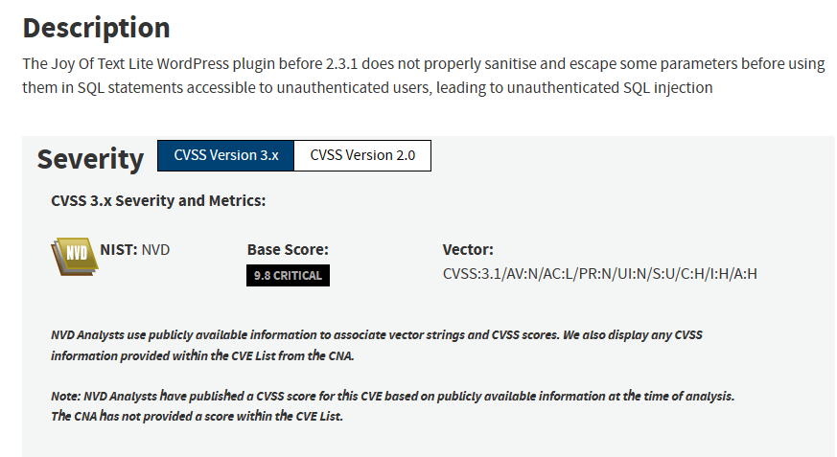

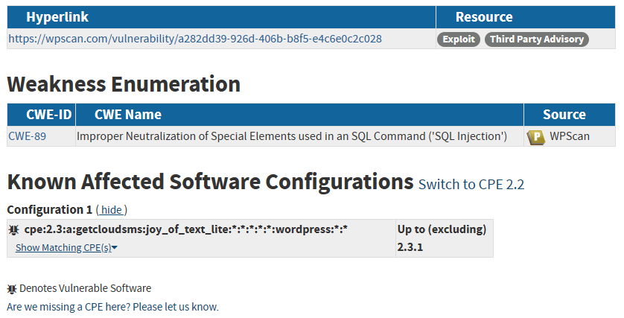

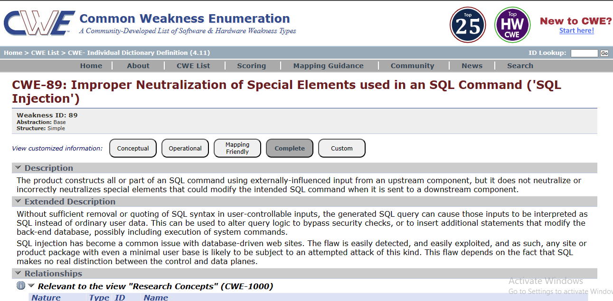

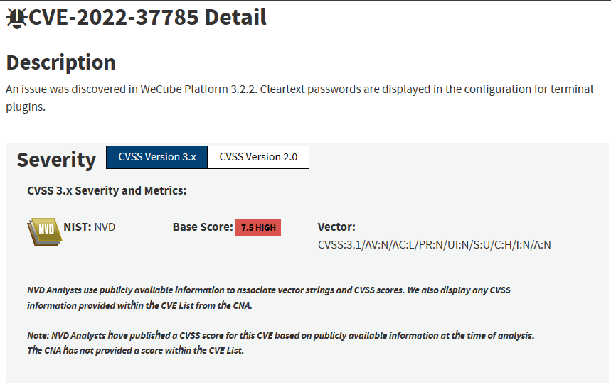

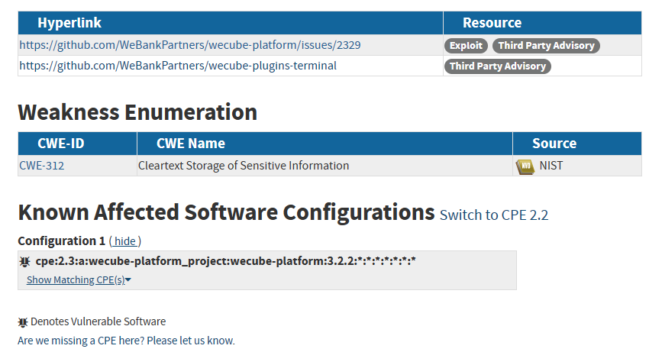

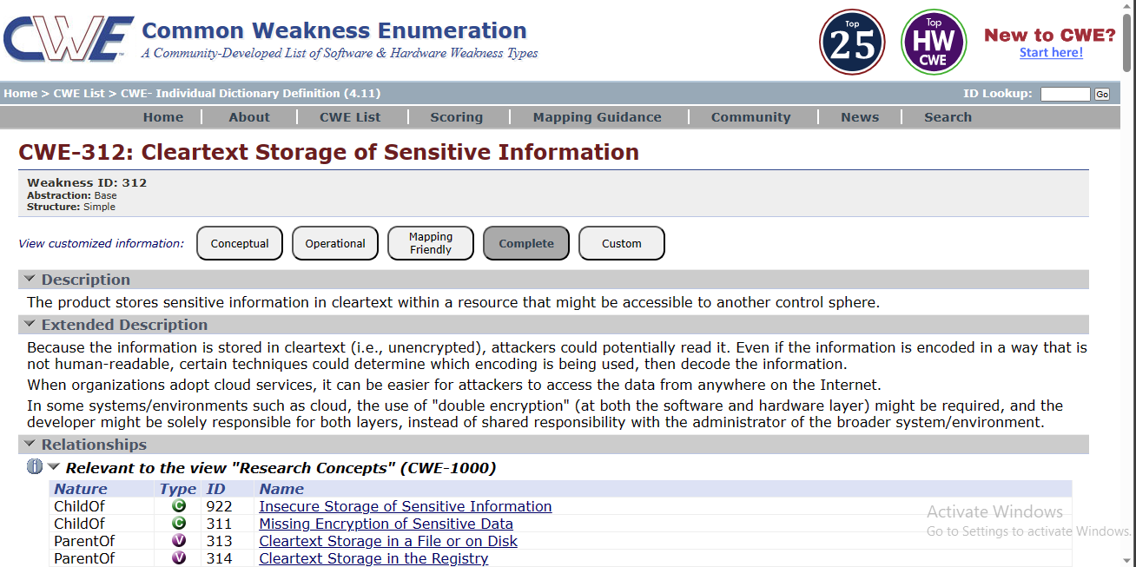

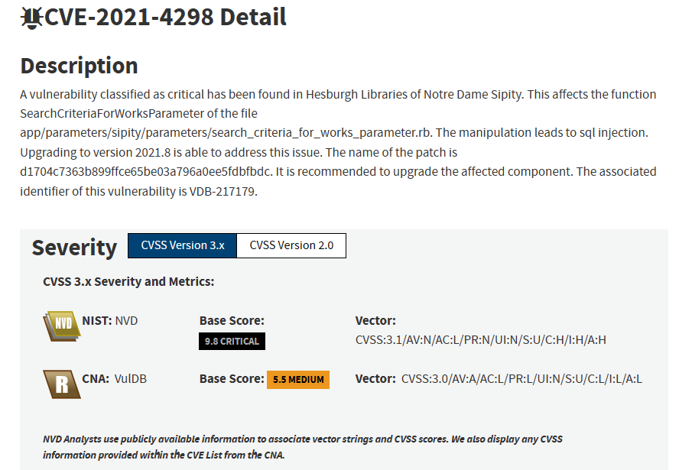

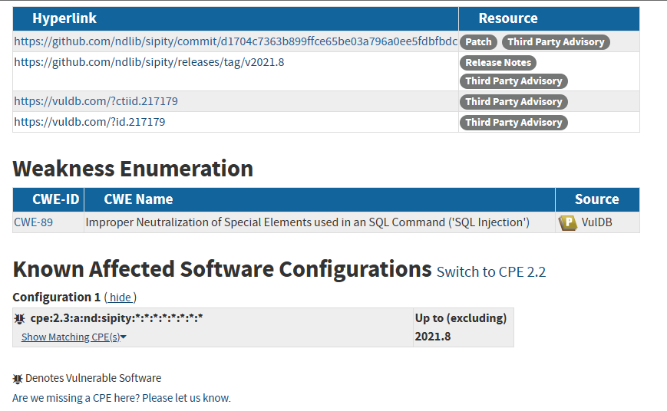

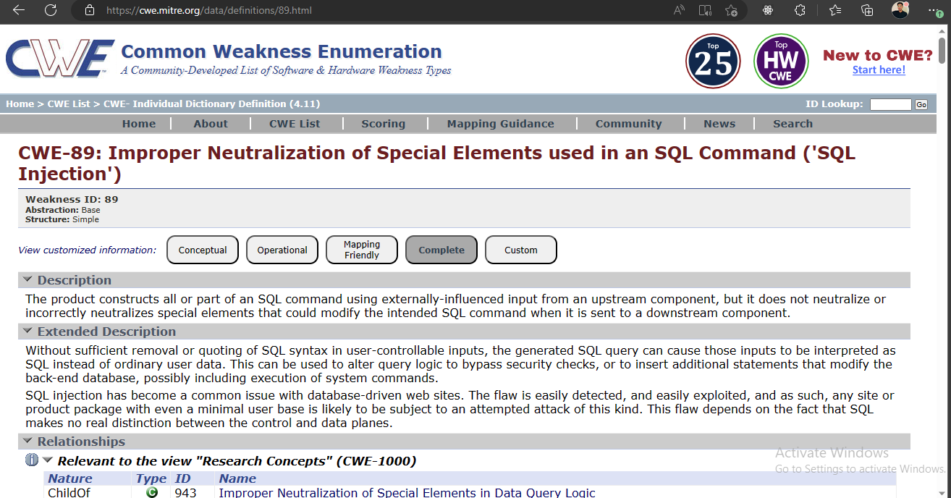

**Task 04.**

VULNERABILITY DISCLOSURE

Disclosing vulnerabilities is a crucial step in maintaining the security of software and hardware systems. When security researchers discover vulnerabilities, they typically report them to the responsible vendor. However, vendors sometimes delay making the vulnerability public for important reasons.

One reason for delay is to allow vendors sufficient time to investigate and address the vulnerability effectively. Thoroughly assessing the vulnerability involves reproducing the issue, conducting detailed analysis, and developing a patch or mitigation strategy. Rushing to disclose a vulnerability without fully understanding its impact or having a viable solution could result in ineffective or incomplete fixes, potentially leaving users even more vulnerable.

Furthermore, vendors may need to coordinate with various stakeholders, including other vendors, partners, or third-party suppliers, to address the vulnerability comprehensively. This coordination process can introduce additional complexities and delays, especially when multiple parties are involved. Allowing vendors the opportunity to engage in this collaborative effort is important to ensure a comprehensive and coordinated response.

Another consideration is the potential for exploitation. Once a vulnerability becomes public, attackers may quickly exploit it before users have a chance to apply the necessary patches or safeguards. By delaying public disclosure, vendors can provide users with a reasonable timeframe to update their systems and protect themselves from potential attacks. This approach balances the need for transparency with the responsibility to minimize the window of opportunity for attackers.

Determining an appropriate timeframe for vulnerability disclosure is challenging and depends on various factors. The severity and exploitability of the vulnerability, the complexity of the affected software or hardware, and the vendor's resources for developing and distributing patches all contribute to this decision. Industry best practices suggest that vendors should aim to release patches within 90 days after being notified of a vulnerability. However, each case should be evaluated individually, considering the specific circumstances involved.

If a vendor fails to make the vulnerability public within a reasonable timeframe, the question arises as to whether the security researcher should disclose it without the vendor's permission. While there is a natural inclination to disclose vulnerabilities to protect users, responsible disclosure practices encourage security researchers to work with vendors through established channels before resorting to full public disclosure. Open lines of communication, such as coordinated vulnerability disclosure programs, provide a framework for reporting vulnerabilities, collaborating with vendors, and ensuring appropriate actions are taken.

Responsible disclosure fosters collaboration between researchers and vendors, allowing vendors to address vulnerabilities promptly and effectively while acknowledging the researcher's contribution. Bug bounty programs also play a vital role in incentivizing researchers to report vulnerabilities directly to vendors by offering rewards, recognition, and legal protections.

In conclusion, vulnerability disclosure is a complex process with multiple considerations. Striking a balance between transparency, effective patching by vendors, and the potential risks of public disclosure requires careful evaluation. Open communication, responsible disclosure practices, and collaborative frameworks facilitate effective vulnerability management, benefiting both vendors and users in the ongoing battle against cyber threats.